M4 - DEVELOP PRESENTATIONS AND SLIDESHOWS

In this part of the course, you’ll discover how to give an effective presentation about your data analysis. This final module teaches you to construct insightful presentations that resonate with your audience. You'll learn to anticipate and address potential questions and to articulate the limitations of your data, ensuring a robust and credible narrative for your stakeholders.

## Learning Objectives

* Describe best practices for addressing the question-and-answer section of a presentation
* Consider the caveats and limitations associated with the data in a presentation
* Differentiate between strong and weak presentation content
* Describe how junior data analysts are expected to use their presentation skills
* Explain principles and practices associated with effective presentations
* Identify appropriate responses to presentation objections

THE ART AND SCIENCE OF PRESENTATIONS

[Pull it all together](https://www.coursera.org/learn/visualize-data/lecture/39woq/pull-it-all-together)

Welcome back. Now that we're in the share phase of the data analysis process, it's time to show other people what we found.

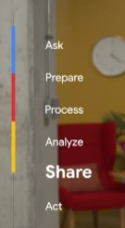

You've already learned about creating data visualizations and how to use data-driven storytelling. Now it's time to talk about actually presenting the data.

Maybe the idea of presenting your findings of stakeholders makes you nervous, or maybe you're getting excited just thinking about it.

Either way, these upcoming videos will get you ready to present like a pro.

Coming up, we'll learn about the art and science of presentations, some best practices you can use for future presentations, and how to bring multiple data sources together to tell the whole story.

As a data analyst, it's important to find answers and make new discoveries during your data analysis, but it's just it's important to share those findings with other people.

So if you're ready, let's get started.

[Present with a framework](https://www.coursera.org/learn/visualize-data/lecture/pCIlZ/present-with-a-framework)

Earlier in this program, you learned how to keep your audience in mind when communicating your data findings. By making sure that you're thinking about who your audience is and what they need to know, you'll be able to tell your story more effectively.

In this video, we'll learn how to use a **strategic framework to help your audience understand the most important takeaways from your presentation**.

**To make your data findings accessible to your audience, you'll need a framework to guide your presentation.** This helps to create logical connections that tie back to the business tasks and metrics.

As a quick reminder, the business task is the question or problem. your data analysis answers.

The framework you choose gives your audience context to better understand your data.

On top of that, it helps keep you focused on the most important information during your presentation.

The framework for your presentation starts with your understanding of the business task.

Raw data doesn't mean much to most people, but if you present your data in the context of the business task, your audience will have a much easier time connecting with it.

This makes your presentation more informative and helps you empower your audience with knowledge. That's why **understanding the business task early on is key**.

Here's an example.

Let's say we're working with a grocery store chain. They've asked us to identify trends and online searches for avocados to help them make seasonal stocking decisions.

During our presentation, we want to make sure that we continue focusing on this task and framing our information with it. Let's check out this example slide presentation. We can begin our presentation by framing it with the business task here.

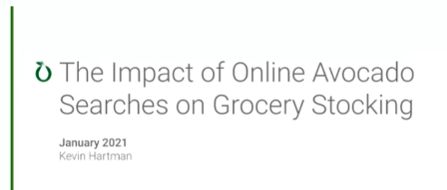

In this second slide, I've added goals for the discussion.

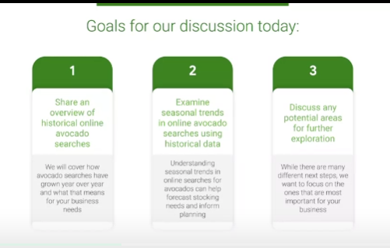

It starts with "share an overview of historical online avocado searches."

Under that, a more detailed explanation: "We'll cover how avocado searches have grown year over year and what that means for your business." Then we'll "examine seasonal trends in online avocado searches using historical data." This is important because "understanding seasonal trends can help forecast stocking needs and inform planning." And finally, "discuss any potential areas for further exploration."

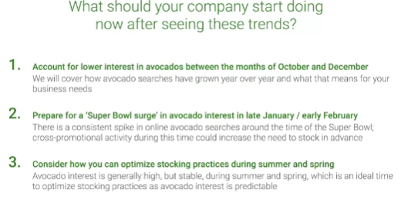

This is where we'll address next steps in the presentation. This clearly outlines the presentation so our audience knows what to expect.

It also lets them know how the information we share is going to be connected to the business task.

You might remember, we talked about telling a story with data before. You can think of this like outlining the narrative. We can do the same thing with our data viz examples. If we're showing this visual graph of annual searches for avocados, we might want to frame it by saying this graph shows the months with the most online searches for avocados last year, so we can expect that this interest in avocados will fall in the same months this year.

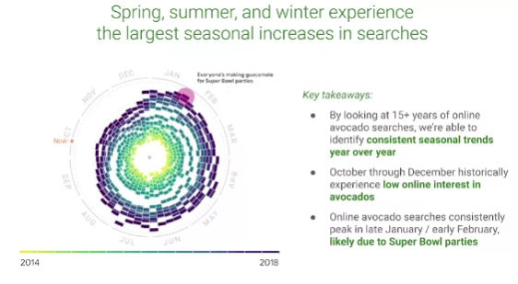

That can even be used in our speaker notes for the slide. This is a great place to add important points you want to remember during the presentation ahead of time. These notes aren't visible to your audience in presentation mode, so they're great reminders you can refer to as you present.

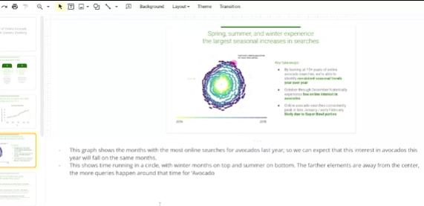

Plus, you could even share your presentation with speaker notes ahead of time to make the content more accessible for your audience.

Using this data, the grocery store can anticipate demand and make a plan to stock enough avocados to match their customers' interests. That's just one way we can use the business task to frame our data and make it easier to understand.

**You also want to make sure you're outlining and connecting with your business metrics** by showcasing what business metrics you use. You can help your audience understand the impact your findings will have.

Think about the metrics we use for our avocado presentation. We track the number of online searches for avocados from different months over several years to anticipate trends and demand.

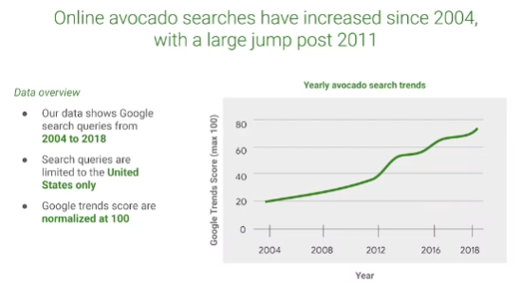

By explaining this in our presentation, it's easy for our audience to understand how we used our data. These data points alone—the dates or number of searches— aren't useful for our audience, but when we explain how they're combined as metrics, the data we're sharing makes so much more sense.

Here's another potential data viz that we want to use.

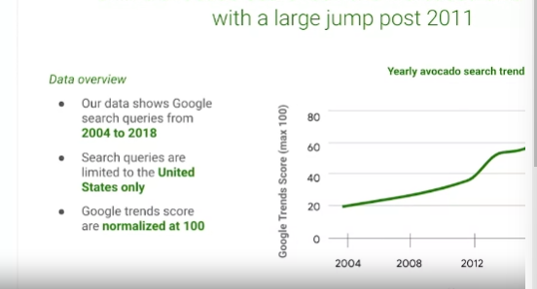

We can frame it for our audience by including some of our metrics. There's an explanation of what time period this data covers: "Our data shows Google search queries from 2004 to 2018." Where we gathered this data from: "Search queries are limited to the United States only." And a quick explanation of how the trends are being measured:

"Google trends scores are normalized at 100." So now that our audience understands the metrics we use to organize this data, they'll be able to understand the graph more clearly. Using a strategic framework to guide your presentation can help your audience understand your findings, which is what the sharing phase of the data analysis process is all about. Coming up, we'll learn even more about how to weave data into your presentations.

[Weave data into your presentation](https://www.coursera.org/learn/visualize-data/lecture/P0cIP/weave-data-into-your-presentation)

Hey, great to have you back. So we know how to use our business tasks and metrics to frame our data findings during a presentation.

Now let's talk about how you work data into your presentations to help your audience better understand and interpret your findings.

First, it's helpful for your audience to understand what data was available during data collection. You can also tell them if any new relevant data has come up, or if you discovered that you need different data.

For our analysis, we used data about online searches for avocados over several years. The data we collected includes all searches with the word "avocado," so it includes a lot of different kinds of searches. This helps our audience understand what data they're actually looking at and what questions they can expect it to answer. With the data we collected on searches containing the word avocado, we can answer questions about the general interest in avocados. But if we wanted to know more about something specific, like guacamole, we'd probably need to collect different data to better understand that part of our search data. Next, you'll want to establish the initial hypothesis. Your initial hypothesis is a theory you're trying to prove or disprove with data. In this example, our business task was to compile average monthly prices. Our hypothesis is that this will show clear trends that can help the grocery store chain plan for avocado demand in the coming year. You want to establish your hypothesis early in the presentation. That way, when you present your data, your audience has the right context to put it in. Next, you'll want to explain the solution to your business tasks using examples and visualizations. A good example is the graph we used last time that clearly visualized the search trend score for the word avocado from year to year. Raw data could take time to sink in, but a good example or visualization can make it much easier for your audience to understand you during a presentation.

Keep in mind, **presenting your visualizations effectively is just as important as the content, if not more**. And that's where the **McCandless Method** we learned about earlier can help.

So let's talk through the steps of this method and then apply them to our own data visualizations. The McCandless Method moves from the general to the specific, like it's building a pyramid:

***First step of the McCandless Method :***introduce the graphic you're presenting by name (this directs your audience's attention).

Let's open the slide deck we were working on earlier.

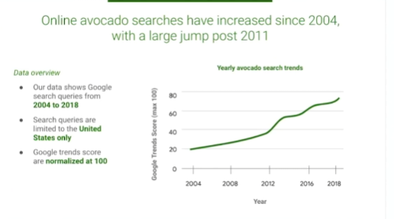

We've got the framework we explored last time and our two data viz examples. According to the McCandless Method, we want to introduce our graphic by name. The name of this graph, "yearly avocado search trends," is clearly written here. When we present it, we'll be sure to share that title with our audience so they know where to focus and what the graphic is all about.

**Second Step of the McCandless Method:** you'll want to answer the obvious questions your audience might have before they're asked.

*Start with the high-level information and work your way into the lowest level of detail that's useful to your audience.*

This way, your audience won't get distracted trying to understand something that could have easily been answered when the graphic was introduced. We added in the information about when, where, and how this data was gathered to frame this data viz.

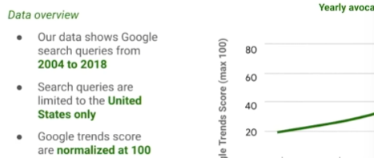

But it also answers the first question many stakeholders will ask, **"Where is this data from, and what does it cover?"**

So going back to the second graph in our presentation, let's think about some obvious questions our audience might have when they see this graph at first.

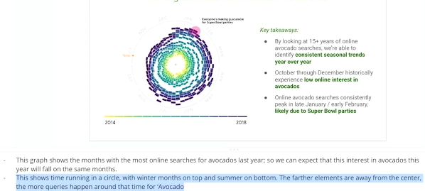

This data viz is really interesting, but it can be hard to understand at a glance, so our audience might have questions about how to read it. Knowing that, we can add an explanation to our speaker notes to answer these questions as soon as this graph is introduced.

Once you've answered any potential questions your audience might have, you'll want to state the insight your data viz provides (it's important to get everyone on the same page before you move into the supporting details), that’s the **third step of the McCandless Method**.

We can write in some key takeaways to this slide to help our audience understand the most important insights from the graphic. Here we let the audience know that this data shows us a consistent seasonal trend year over year. We can also see that there's low online interest in avocados from October through December. This is an important insight that we definitely want to share.

Even though avocados are a seasonal summer fruit, searches peak in January and February. For a lot of people in the United States, watching the Super Bowl and eating chips with guacamole is popular this time of year. Now our audience knows what takeaways we want them to have before moving on.

**The fourth step in the McCandless Method** is calling out data to support that insight.

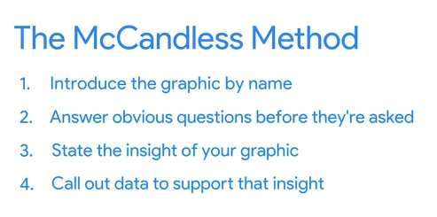

This is your chance to really wow your audience, so give as many examples as you can. With our avocado graphs, it might be worth pointing to specific examples. In our monthly trends graph, we can point to specific weeks recorded here. "During the week of November 25th, 2018, the search score was around 49, but the week of February 4th the search score was 90. This shows the rise and fall of online search interest, with the help of some of the very cool data in our graphs."

Finally, it's time to tell your audience why it matters. **This is the "so what" moment and the Fifth Step of the McCandless Method**.

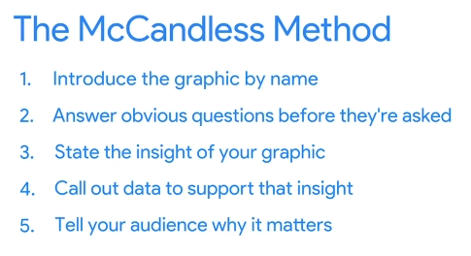

Why is this insight interesting or important to them?

This is a good time to present the possible business impact of the solution and clear action stakeholders can take. You might remember that we outlined this in our framework at the beginning of our presentation. So let's explain what this data helps our grocery store stakeholders do.

First, they can account for lower interest in avocados between the months of October and December. They can also prepare for the Super Bowl surge in avocado interest in late January/early February. And they'll be able to consider how to optimize stocking practices during summer and spring. There's a little more detail under each of these points, but this is a basic breakdown of the impact. And that's how we use the McCandless Method to introduce data visualizations during our presentations.

I have one more piece of advice. **Take a second to self-check and ask yourself, "Does this data point or chart support the point I want people to walk away with?" It's a good reminder to think about your audience every time you add data to a presentation**.

So now you know how to present data using a framework, and weave data into your presentation for your audience. And you got to learn the McCandless Method for data presentation. Coming up, we'll learn some best practices for actually creating presentations. See you soon.

[Review a slide presentation](https://www.coursera.org/learn/visualize-data/supplement/FThSi/review-a-slide-presentation)

You have started learning how to create effective slide presentations to share your findings. In this reading, you’ll develop a rubric to help you evaluate slide presentations. By the end of this reading, you will have a stronger understanding of how to create an effective slide presentation using best practices from this course. This will help you evaluate your own work.

## **Your evaluation criteria**

When exploring a slide presentation, use your knowledge of effective presentation practices to evaluate it. This includes reviewing your own work! When you’re checking over slide presentations, there are some best practices you can check for:

* **Include a title, subtitle, and date:** Making sure that your slide deck presentation has a title, subtitle, and date makes sure that your audience knows exactly what you are presenting and when the information was from. That way they know it’s relevant and current to them!
* **Use a logical sequence of slides:** Organizing your slides in an order that makes sense guides your audience through your narrative, building understanding step by step.
* **Provide an agenda with a timeline:** An agenda offers a roadmap of your presentation, allowing your audience to follow along and anticipate key topics.
* **Limit the amount of text on slides:** Keeping text brief ensures clarity and retains the audience’s attention; aim for your audience to scan it within 5 seconds.
* **Start with the business task:** By immediately relating the content to the business task at hand, you contextualize your information, making it relevant and actionable.
* **Establish the initial hypothesis:** Presenting an initial hypothesis gives your audience a starting point for what to expect and frames the subsequent analysis.
* **Show what business metrics you used:** Clarifying which metrics you're analyzing validates your arguments and helps the audience gauge your presentation's relevance to business outcomes.
* **Use visualizations:** Visual aids can illustrate complex data more effectively than text alone, making your message more accessible.
* **Introduce the graphic by name:** A brief introduction to each graphic aids in understanding and retaining information.
* **Provide a title for each graph:** Titles act as signposts, helping the audience quickly grasp the meaning of each visual.
* **Go from the general to the specific:** Starting with a broad overview before diving into details ensures that all audience members are on the same page.
* **Use speaker notes to help you remember talking points:** Notes act as your cue cards, enabling a smoother delivery and ensuring no critical point is missed.
* **Include key takeaways:** Summarizing the main points at the end of your presentation reinforces the message and ensures the audience leaves with the intended takeaways.

Like so many parts of your job as a data professional, creating presentations is an iterative process. Reviewing your work, making changes as needed, and improving it when you can will make your presentations clearer and more useful for stakeholders.

## **Create an evaluation table**

Now that you have an understanding of what best practices you are trying to apply to slide presentations, organize your reviews using an evaluation table. An evaluation table essentially gives you a checklist for each slide in a presentation so you can identify any changes that need to be made in an organized fashion. The evaluation table should have a column for the slide number, a column for you to take notes on what worked well, and a column for what could be improved. Here’s an example of a blank evaluation table: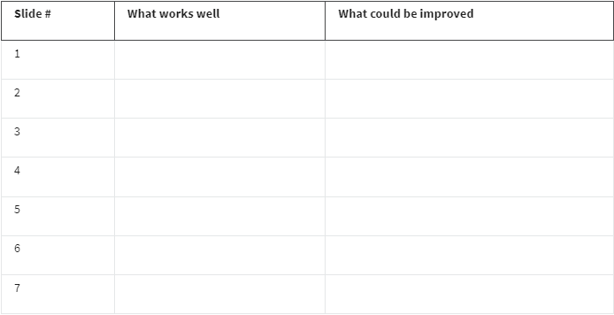

You can use evaluation tables to note things you liked about a presentation as well as things you would like to improve!

## **Key takeaways**

Refining your skills in evaluating slide decks is an evolving journey. Each aspect of your presentation—from a concise title to a coherent sequence of content, and the conciseness of your text to the accuracy of your visuals—is intentionally designed to elevate the audience's understanding and interest. Documenting your progress and taking time for reflection supports your development and is fundamental to communicating complex data in a clear, impactful narrative. And to improve your presentation skills for the future!

[Brittany: Presentation skills for new data analysts](https://www.coursera.org/learn/visualize-data/lecture/mjF9z/brittany-presentation-skills-for-new-data-analysts)

My name is Brittany, and I'm an Analytical Lead at Google. One of the tips that I have is to try to **keep things "kindergarten simple."** And what that means is, keep the concepts that you're presenting as simple and as straightforward as possible.

Whenever you enter a room, there are going to be people within that room of varying interest levels, varying knowledge levels. They have different levels of subject matter expertise. Nobody wants to present to a room whose eyes are glazing over. My pet peeve about seeing certain presentations with data is that they often will include what I like to call "eyesore charts." And what an eyesore chart is, it has way too much data, has way too many colors, it just looks busy, and you just really can't figure out what the presenter is actually trying to say.

Another tip that I have is to **make your presentation fun**. So nobody wants to be in a room where you are talking for a full hour, and the only voice that you're hearing is your own. One of the things that I try to do to break it up is I try to think of little fun games or quizzes, or I'll **play a video or ask questions to the audience** just to make sure that they're fully engaged and that they are talking back to me.

Another tip that I try to **incorporate into my presentations is storytelling**. Everybody loves a good story, and when you do it right, you are able to connect and make your audience engage in a way that they probably wouldn't if you weren't telling that story.

The last tip that I have is **make sure that you have an ally in the room**. Oftentimes before I'm giving a really big data presentation, I will find one or two people that I know are going to be in the room and present my content to them ahead of time. And what that does is it allows me to not only get feedback, but it also allows me to make sure that someone else is nodding their head and aligned to the numbers that I'm about to present. And I can't even tell you how many times that I've been in presentations where those allies have really come to my rescue. When the room asks a lot of questions or is potentially trying to poke holes in the analysis, those allies are there to speak up, and they really are going to have your back and lend credibility to what it is that you're presenting.

The most challenging part of my job would be the fact that I am there to convince people to do something that they might not be fully confident that they should be doing. And a lot of times, it takes multiple conversations, multiple rounds of convincing, for someone to actually come around to what I was trying to articulate or get them to do. When you have spent maybe six months or a year building an analysis and building a story and building a narrative for someone to apply to their strategies, and they actually come around and they actually do it, that makes the challenges worth it.

[Step-by-Step: Critique of a presentation](https://www.coursera.org/learn/visualize-data/supplement/EHWS8/step-by-step-critique-of-a-presentation)

This reading provides an orientation of two upcoming videos:

* **Connor: Messy example of a data presentation**
* **Connor: Good example of a data presentation**

To get the most out of these videos, you should watch them together (back to back). In the first video, Connor introduces a presentation that is confusing and hard to follow. In the second video, he returns to talk about what can be done to improve it and help the audience better understand the data and conclusions being shared.

## **Messy data presentation**

In the first video, watch and listen carefully for the specific reasons the “messy” presentation falls short. Here is a preview:

* No story or logical flow
* No titles
* Too much text
* Inconsistent format (no theme)
* No recommendation or conclusion at the end

### **Messy presentation: people don’t know where to focus their attention**

The main problem with the messy presentation is the lack of a logical flow. Notice also how the data visualizations are hard to understand and appear without any introduction or explanation. The audience has no sense of what they are looking at and why. When people in the audience have to figure out what the data means without any help, they can end up being lost, confused, and unclear about any actions they need to take.

## **Good data presentation**

In the second video, numerous best practices are applied to create a better presentation on the same topic. This “good” presentation is so much easier to understand than the messy one! Here is a preview:

* Title and date the presentation was last updated
* Flow or table of contents
* Transition slides
* Visual introduction to the data (also used as a repeated theme)
* Animated bullet points
* Annotations on top of visuals
* Logic and progression
* Limitations to the data (caveats) - what the data can’t tell you

**Tip:** As you watch this video, take notes about what Connor suggests to create a good presentation. You can keep these notes in your journal. When you create your own presentations, refer back to your notes. This will help you to develop your own thinking about the quality of presentations.

### **Good presentation: people are logically guided through the data**

The good presentation logically guides the audience through the data – from the objectives at the beginning all the way to the conclusions at the end. Notice how the data visualizations are introduced using a common theme and are thoughtfully placed before each conclusion. A good presentation gives people in the audience facts and data, helps them understand what the data means, and provides takeaways about how they can use their understanding to make a change or do some good.

## **Up next**

Get started with the messy vs. goodpresentation comparison by viewing the first video: [Connor: Messy example of a data presentation](https://www.coursera.org/learn/visualize-data/lecture/SYW63/connor-messy-example-of-a-data-presentation).

[Connor: Messy example of a data presentation](https://www.coursera.org/learn/visualize-data/lecture/SYW63/connor-messy-example-of-a-data-presentation)

So we're going to dive into specific examples that we have. So we've built what we call a messy example of a data presentation. We'll walk through each slide and the presentation as a whole to understand why it doesn't actually work well for explaining a specific analysis. We have a title slide: "The Relationship Between Health and Happiness Around the World."



Right off the bat, there is a very generic picture about the world. It is a very lengthy title. We know what we're going to be talking about, but there's nothing here that's really compelling about the presentation.

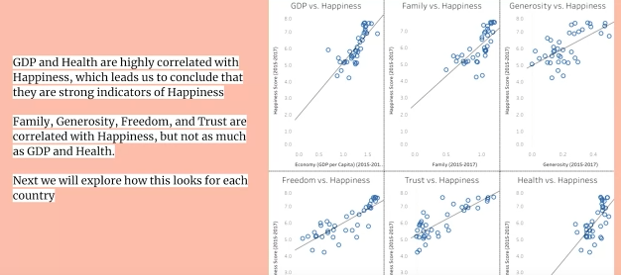

The first slide, when we are looking at a data presentation, we have immediately put a lot of data in front of them and a lot of text in front of them. Right now they don't know what they're looking at. There was no statement of purpose. We don't have an introduction slide. They don't know who I am. They don't know why they're there. What are we talking about? Why are we talking about it? What should they walk away with? There's none of that—we've just immediately gone into the specific data visuals that we are showing them. Now, an important aspect of every slide is also to have a title. Now, title, subtitle, these things help people understand exactly what this slide is going to be discussing so that they know what they're trying to understand as you are talking. So immediately getting here, the audience is going to be lost. They're going to be trying to read the slide. They're going to be trying to decipher what the visuals mean. It's important for you to make sure there's not too much going on. Now if we move on to the next slide, what we're looking at here —the visual is better, it's easier to understand. There's not more than one of them. We have a map. We have visual colors to represent the numeric values within them. But again, there's nothing for them to really understand.

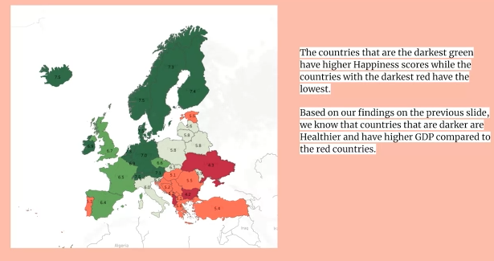

Now this is where you can explain within the speaker notes. But you also have, again, a lot of words, no title. What is it that they are really trying to get from this slide? Part of a good presentation, as well, is the theme that you have or a consistent theme. So you've now switched sides of the specific visual. You have the text on the other side. Doesn't mean you can't do it, but what you're really trying to do throughout a presentation is build some familiarity, especially with data analytics. You're building familiarity with the visuals that you're showing them—the data. By the end of the presentation, they should understand the data or the concept as much as you do.

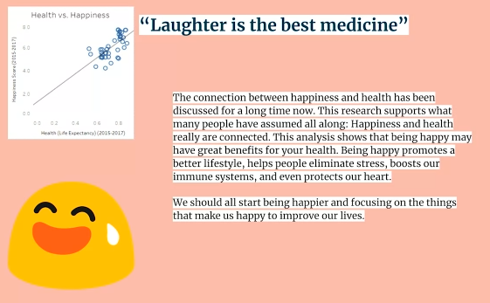

Finally, we have the conclusion slide. This one does have a title: "Laughter is the best medicine." We understand again what it is that we're looking at, but there is no logical flow and how to get here.

Was this overall presentation compelling? We put two slides there. We had too much text. We didn't really explain anything about it. Again, there's awkward placement on where all of these things are within the slide itself. When you're thinking about building a presentation, you should think about it from the audience's point of view. The only thought that's going through their head is, "Where should my focus be? As I'm trying to listen, as I'm trying to comprehend, where should I be looking?" If you have slides like we just showed you, they don't know where they should be looking or they're going to spend their time reading and trying to comprehend while you're also talking. It's very important that you are directing their gaze and directing the audience so that they know exactly what they should be listening to, what they should be trying to understand, and you are guiding them through to the overall conclusion.

So to sum up in terms of what is wrong with this overall presentation and not just what you're going to be talking about or what you are trying to conclude, but just the overall placement of the data visuals and the visuals that you chose.

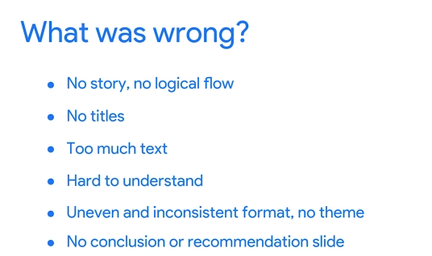

The main thing is there was no story, no logical flow. You started with a bunch of scatterplots and a lot of text and you moved on to the heatmap of the happiness scores, but without somebody presenting something, without any idea of the concept behind what they are trying to conclude. You didn't have titles, there's too much text, it's very difficult to understand, and it was uneven and inconsistent. Even if you had a really good explanation on each slide, you might have lost the audience because what they were trying to do, what they were trying to understand, is what was the slide trying to tell them? Finally, the most important part of any data analytics presentation is the recommendation or conclusion slide. You had that, but there was no title. They didn't know that this was the end of the presentation, that this is where they should be trying to put all the pieces together. Coming up, we're going to discuss how we can improve this presentation, as well as dive into what the presentation will actually look like when we're trying to explain how health and happiness are correlated.

[Connor: Good example of a data presentation](https://www.coursera.org/learn/visualize-data/lecture/ZJP4T/connor-good-example-of-a-data-presentation)

Quase acabandooooo

[Evaluation practice](https://www.coursera.org/learn/visualize-data/discussionPrompt/EFkKP/evaluation-practice)

PRESENTATION SKILLS AND PRACTICES

[Proven presentation tips](https://www.coursera.org/learn/visualize-data/lecture/EKyBG/proven-presentation-tips)

[Self-Reflection: Examples of great presentations](https://www.coursera.org/learn/visualize-data/quiz/p7SVL/self-reflection-examples-of-great-presentations)

[Guide: Share data findings in presentations](https://www.coursera.org/learn/visualize-data/supplement/LFLIP/guide-share-data-findings-in-presentations)

[Evaluate your presentation](https://www.coursera.org/learn/visualize-data/supplement/igsQe/evaluate-your-presentation)

[Present like a pro](https://www.coursera.org/learn/visualize-data/lecture/uJwZx/present-like-a-pro)

[Presentation debrief](https://www.coursera.org/learn/visualize-data/discussionPrompt/hlnzr/presentation-debrief)

[Test your knowledge on presentation skills and practices](https://www.coursera.org/learn/visualize-data/quiz/3Py4U/test-your-knowledge-on-presentation-skills-and-practices)

DATA CAVEATS AND LIMITATIONS

[Prepare for the Q&A](https://www.coursera.org/learn/visualize-data/supplement/RI0Cu/prepare-for-the-q-a)

[Anticipate the question](https://www.coursera.org/learn/visualize-data/lecture/wulTO/anticipate-the-question)

[Handle objections](https://www.coursera.org/learn/visualize-data/lecture/BxgQQ/handle-objections)

[Self-Reflection: Practice handling objections](https://www.coursera.org/learn/visualize-data/quiz/zbo1D/self-reflection-practice-handling-objections)

[Test your knowledge on caveats and limitations to data](https://www.coursera.org/learn/visualize-data/quiz/QNVZa/test-your-knowledge-on-caveats-and-limitations-to-data)

LISTEN, RESPOND, AND INCLUDE

[Q&A best practices](https://www.coursera.org/learn/visualize-data/lecture/pA1FW/q-a-best-practices)

[Ask for feedback](https://www.coursera.org/learn/visualize-data/discussionPrompt/byLQe/ask-for-feedback)

[Connor: Becoming an expert data translator](https://www.coursera.org/learn/visualize-data/lecture/uSisr/connor-becoming-an-expert-data-translator)

[Test your knowledge on listening, responding, and including](https://www.coursera.org/learn/visualize-data/quiz/ep87O/test-your-knowledge-on-listening-responding-and-including)

MODULE 4 CHALLENGE

[Glossary terms from module 4](https://www.coursera.org/learn/visualize-data/supplement/Adbqw/glossary-terms-from-module-4)

[Module 4 challenge](https://www.coursera.org/learn/visualize-data/exam/T1Uta/module-4-challenge)

COURSE WRAP-UP

[Course 6 glossary](https://www.coursera.org/learn/visualize-data/supplement/DLisR/course-6-glossary)

[Congratulations! Course wrap-up](https://www.coursera.org/learn/visualize-data/lecture/6azVn/congratulations-course-wrap-up)

[Coming up next...](https://www.coursera.org/learn/visualize-data/supplement/e0mXc/coming-up-next)